BFS without Queue & without Node

Python.file:

Screenshot:
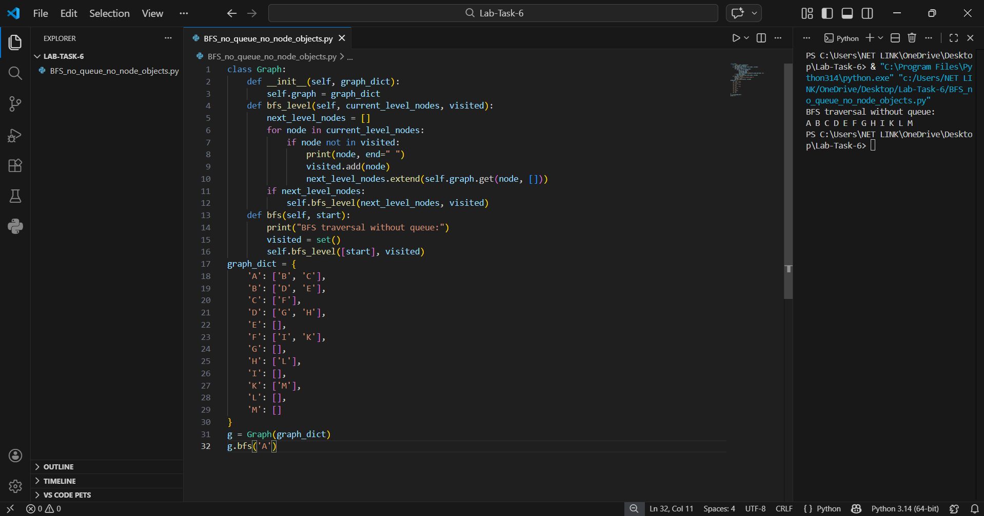

Details:
This Python program implements the Breadth First Search (BFS) traversal on a Graph.
It allows the user to:
• Create a graph using a dictionary
• Traverse the graph using BFS
• Display traversal output
• Run the program in the terminal
The program does not use a queue. Instead, it uses recursion for level-wise traversal.

Main Components:
• Class: Graph
• Dictionary used to store graph: self.graph
• Method to perform traversal: bfs()
• Helper method: bfs_level()
• Set used to track visited nodes: visited = set()

How the Program Works:

1️. Start:
• The program creates a graph using a dictionary (adjacency list format).
• An object of the Graph class is created.
• The bfs(“A”) method is called to start traversal from node A.

2️. Graph Creation:
• The graph is defined using a dictionary.
• Each key represents a node.
• Each value represents its neighbouring nodes.
• The graph is directed (for example: A → B, A → C).

3️. BFS Traversal:
• bfs(start) method is called.
• A visited set is created to store visited nodes.
• The first level contains only the starting node.
• The helper function bfs_level() is called.

4️. BFS Logic (Without Queue):
• Current level nodes are passed as a list.
• Each node is checked:
- If not visited → print it
- Mark it as visited
- Add its neighbours to next level list
• Recursive call is made for next level nodes.
• The process continues until no nodes remain.

